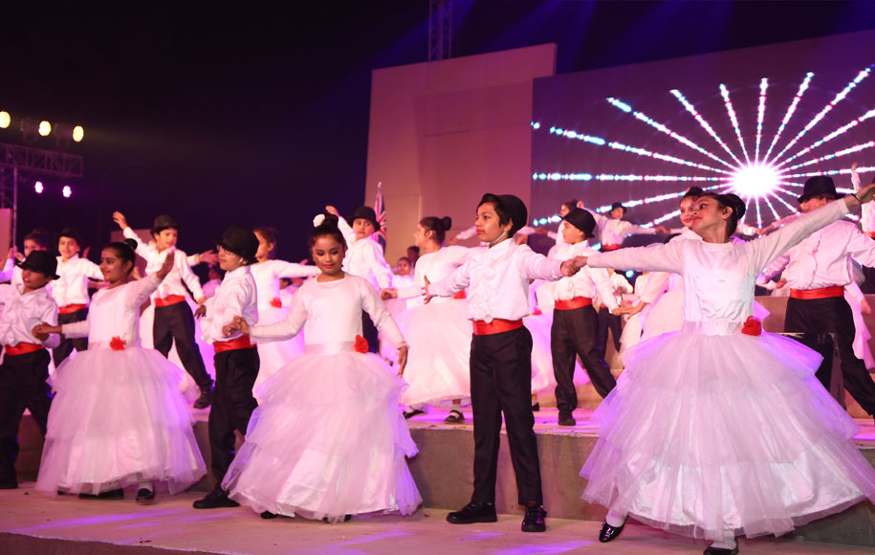**About Us**

**Message From The School Governing Council**

Welcome to The Maurya School, Palam Vihar, Gurgaon! The Maurya School is about the freedom to experiment, to think differently, and be an individual. We are all proud of our school and hope that you will come to share that feeling with us. Through this website, we have tried to set out a view of life at The Maurya School, the activities and opportunities that are available to the children. The prime aim of our school is to give each child the opportunity to develop his/her own potential, by laying down foundations of a balanced education. We teach children to appreciate the needs of others and understand that both inside and outside the school, we have responsibilities as well as rights. In other words, any child who is admitted here will be transformed not just in thoughts but in deeds as well.